DSA0601 • DATA HANDLING AND VISUALIZATION

LAB EXPERIMENT RECORD
SET 16 – CUSTOMER DEMOGRAPHICS ANALYSIS

Department | AIDS
Course Code / Course Name | DSA0601 / Data Handling and Visualization
Experiment | Data Visualization using R
Name | M.Teja kumar
Register Number | 192424308
Date | 10 October 2026
Day | Saturday

Aim
To analyze customer demographic data using a bar chart, pie chart, demographic data table, and an interactive dashboard in RStudio.

Dataset

Customer ID | Age | Gender | Income (in $)
1 | 28 | Female | 50,000
2 | 35 | Male | 60,000
3 | 42 | Female | 75,000

Experiment Overview
- Program 1: Create a bar chart to visualize the distribution of customer ages.
- Program 2: Generate a pie chart to represent the distribution of customers by gender.
- Program 3: Build a table to show the demographic information for each customer.
- Program 4: Develop an interactive dashboard combining the bar chart, pie chart, and table.
The dataset contains three customer records. The visualizations and conclusions in this record are therefore limited to the supplied sample.

PROGRAM 1: Bar Chart – Distribution of Customer Ages
Aim: To create a bar chart to visualize the distribution of customer ages, with Customer ID on the x-axis and Age on the y-axis.

Required Packages
# No external package is required
# The program uses base R barplot().

R Program
#
# SET 16 - PROGRAM 1
# Customer Age Distribution #

# Dataset
customer_id <- c(1, 2, 3)
age <- c(28, 35, 42)
gender <- c("Female", "Male", "Female") income <- c(50000, 60000, 75000)
customer_data <- data.frame( Customer_ID = customer_id, Age = age,
Gender = gender, Income = income
)
# Display dataset print(customer_data)

# Bar Chart barplot(
customer_data$Age,
names.arg = customer_data$Customer_ID, main = "Distribution of Customer Ages", xlab = "Customer ID",
ylab = "Age",
col = "lightblue", border = "black"
)

Output

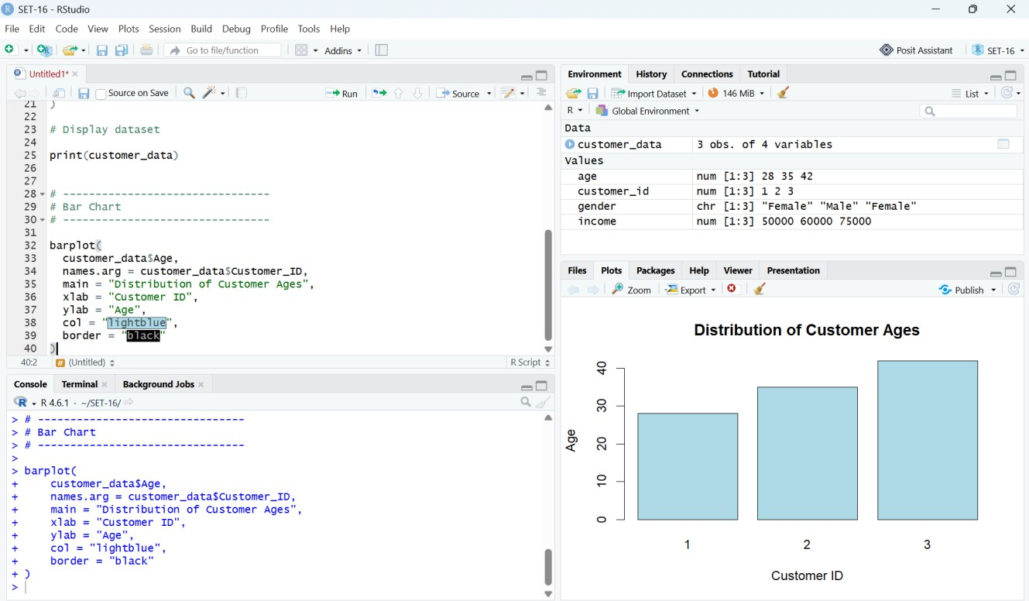

Output 1: Distribution of Customer Ages – RStudio Execution Screenshot

Observation
The bar chart displays the ages of the three customers. Customer 1 is 28 years old, Customer 2 is 35 years old, and Customer 3 is 42 years old. Therefore, Customer 3 has the highest age and Customer 1 has the lowest age in the supplied dataset.

Result
The customer age distribution was successfully visualized using a bar chart in RStudio.

PROGRAM 2: Pie Chart – Distribution by Gender
Aim: To generate a pie chart representing the distribution of customers by gender and display the category counts as labels.

R Program
#
# SET 16 - PROGRAM 2
# Gender Distribution #

# Dataset
customer_id <- c(1, 2, 3)
age <- c(28, 35, 42)
gender <- c("Female", "Male", "Female") income <- c(50000, 60000, 75000)

customer_data <- data.frame( Customer_ID = customer_id, Age = age,
Gender = gender, Income = income
)
# Calculate Gender Frequency
gender_count <- table(customer_data$Gender) print(gender_count)
# Pie Chart pie(
gender_count, labels = paste(
names(gender_count), gender_count,
sep = " : "
),
main = "Distribution of Customers by Gender", col = c("lightpink", "lightblue")
)

Output
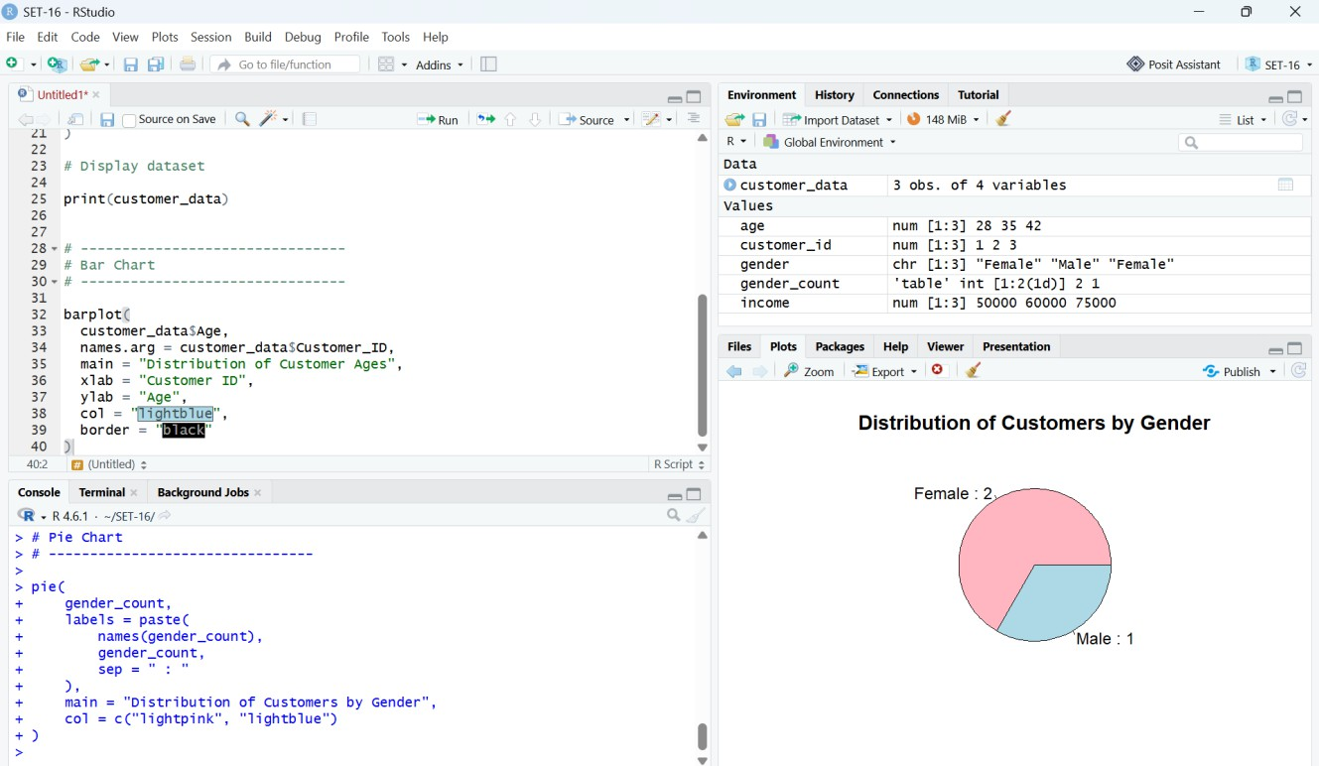

Output 2: Distribution of Customers by Gender – RStudio Execution Screenshot

Observation
The pie chart shows two female customers and one male customer. Hence, females account for 2 out of 3 records (66.67%) and males account for 1 out of 3 records (33.33%) in the supplied sample.

Result
The gender distribution was successfully represented using a pie chart in RStudio.

PROGRAM 3: Customer Demographic Data Table
Aim: To build and display a table containing Customer ID, Age, Gender, and Income for each customer.

R Program
#
# SET 16 - PROGRAM 3
# Customer Demographic Table #
# Dataset
customer_id <- c(1, 2, 3)
age <- c(28, 35, 42)
gender <- c("Female", "Male", "Female") income <- c(50000, 60000, 75000)
# Create Data Frame customer_data <- data.frame(
Customer_ID = customer_id, Age = age,
Gender = gender, Income = income
)

# Display Table print(customer_data)

Output
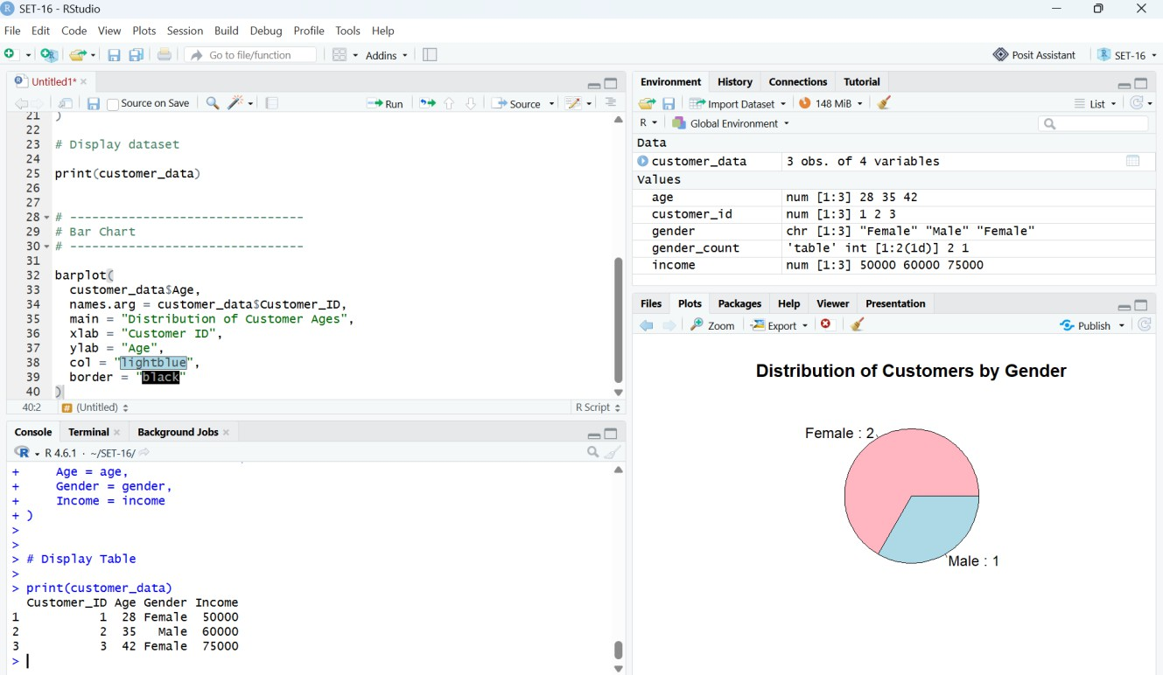

Output 3: Customer Demographic Data – RStudio Console Screenshot

Output Table

Customer ID | Age | Gender | Income
1 | 28 | Female | 50,000
2 | 35 | Male | 60,000
3 | 42 | Female | 75,000

Observation

The table provides the exact demographic values for all three customers. It supports direct comparison of age, gender, and income across the records.

Result
The customer demographic data was successfully organized and displayed as a table in RStudio.

PROGRAM 4: Interactive Customer Demographics Dashboard
Aim: To develop an interactive dashboard combining the customer age bar chart, gender pie chart, and demographic table. The dashboard is implemented using Shiny in RStudio.

Required Packages
install.packages("shiny") install.packages("ggplot2")

R Program
# ========================================== # SET 16 - PROGRAM 4
# CUSTOMER DEMOGRAPHICS DASHBOARD
# ==========================================
library(shiny) library(ggplot2)

# DATASET
customer_id <- c(1, 2, 3)
age <- c(28, 35, 42)
gender <- c("Female", "Male", "Female") income <- c(50000, 60000, 75000)

customer_data <- data.frame( Customer_ID = customer_id, Age = age,
Gender = gender, Income = income
)
# USER INTERFACE
ui <- fluidPage(
titlePanel("Customer Demographics Dashboard"),

sidebarLayout( sidebarPanel(
selectInput( "selected_customer", "Select Customer:",
choices = c("All Customers", customer_id), selected = "All Customers"
)
),
mainPanel( fluidRow(
column( 6,
h3("Customer Age Distribution"), plotOutput("age_plot")
),

column( 6,
h3("Gender Distribution"), plotOutput("gender_plot")
)
),
hr(),
h3("Customer Demographic Data"), tableOutput("customer_table")
)
)
)

# SERVER
server <- function(input, output) { filtered_data <- reactive({

if (input$selected_customer == "All Customers") { customer_data
} else { customer_data[
customer_data$Customer_ID == as.numeric(input$selected_customer),
]
}

})
# BAR CHART
output$age_plot <- renderPlot({
data <- filtered_data() ggplot(
data, aes(
x = factor(Customer_ID), y = Age
)
) +
geom_bar(
stat = "identity", fill = "lightblue", color = "black"
) +
geom_text( aes(label = Age), vjust = -0.5
) +
labs(
title = "Distribution of Customer Ages", x = "Customer ID",
y = "Age"
) +
theme_minimal()
})
# PIE CHART
output$gender_plot <- renderPlot({ data <- filtered_data() gender_count <- table(data$Gender)
pie(
gender_count, labels = paste(
names(gender_count), gender_count,
sep = " : "
),
main = "Distribution of Customers by Gender", col = c("lightpink", "lightblue")
)
})

# DATA TABLE
output$customer_table <- renderTable({ data <- filtered_data()
data.frame(
Customer_ID = data$Customer_ID, Age = data$Age,
Gender = data$Gender, Income = data$Income
)
})
}
# RUN APPLICATION
shinyApp( ui = ui,
server = server
)

Output
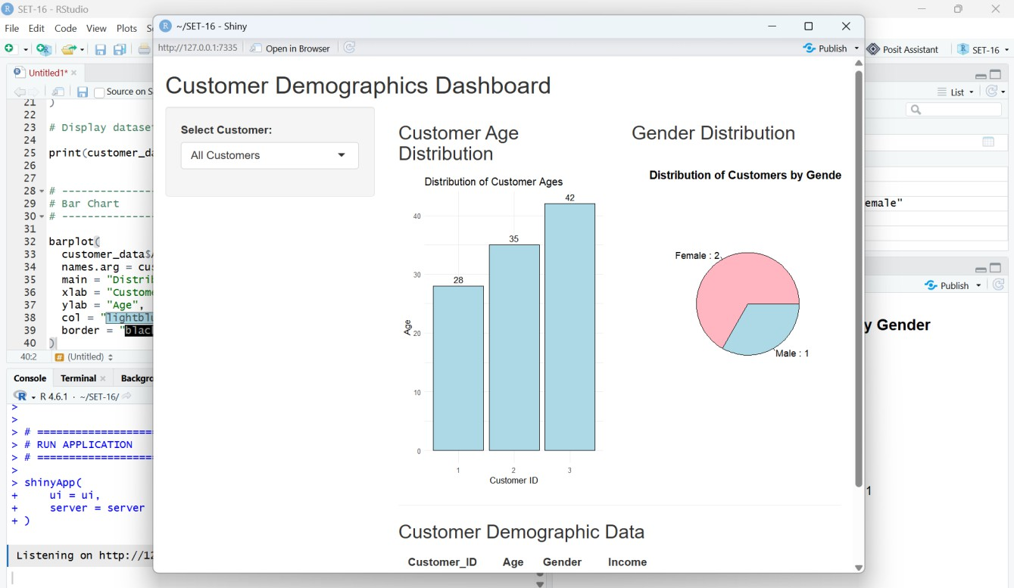
Output 4: Customer Demographics Dashboard – Shiny Execution Screenshot

Dashboard Features
- Customer selector: allows the user to select All Customers or an individual customer.
- Age distribution: displays customer age using a bar chart.
- Gender distribution: displays the gender composition using a pie chart.
- Demographic table: displays Customer ID, Age, Gender, and Income.
- Reactive filtering: selecting a customer updates the displayed visualizations and table.

Observation
The supplied screenshot shows the Shiny application running locally. The dashboard contains the customer selector, customer age distribution, gender distribution, and customer demographic table. With All Customers selected, the bar chart shows ages 28, 35, and 42, while the pie chart shows Female = 2 and Male = 1.

Result
The interactive customer demographics dashboard was successfully executed in RStudio using Shiny and combines the required bar chart, pie chart, and demographic table.

Procedure
- Create vectors for Customer ID, Age, Gender, and Income.
- Combine the vectors using data.frame() to create the customer demographic dataset.
- Use base R barplot() to visualize customer ages.
- Use table() and pie() to visualize the distribution of customers by gender.
- Use print() to display the demographic data table.
- Install and load Shiny and ggplot2 for the interactive dashboard.
- Create the dashboard interface using fluidPage(), sidebarLayout(), selectInput(), plotOutput(), and tableOutput().
- Use reactive() to filter the dashboard according to the selected customer.
- Run the Shiny application and verify the bar chart, pie chart, and table.

Overall Insights
- The supplied sample contains three customers.
- Customer 3 has the highest age at 42 years.
- Customer 1 has the lowest age at 28 years.
- There are two female customers and one male customer.
- The female proportion is 66.67% and the male proportion is 33.33% within this sample.
- Customer 3 has the highest income at $75,000, while Customer 1 has the lowest income at $50,000.
- The dashboard provides a combined view and allows the user to filter the displayed information by customer.

Result
The customer demographic dataset was successfully analyzed in RStudio using a bar chart, pie chart, demographic data table, and an interactive Shiny dashboard. The four visualizations satisfy the requirements of SET 16.

Important Submission Note
The inserted screenshots are the RStudio execution screenshots supplied with this submission. The dashboard screenshot shows the Shiny application running locally and therefore provides execution evidence for Program 4.

